Introduction to graphics

Computer coordinate system:

This is our cartesian coordinate system, with which most of us are familiar and specifically use it for drawing graphs.
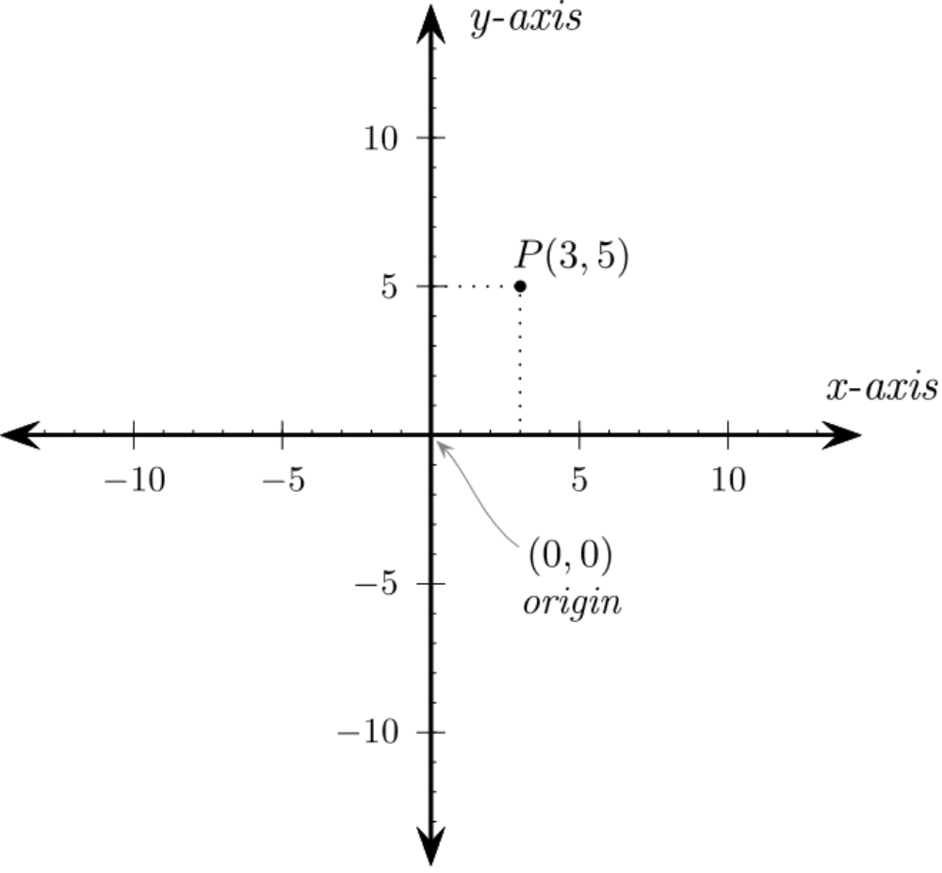
Since we can control individual pixel,the pixel based computer coordinate system came into existence
Computer coordinate system is different from Cartesian coordinate system in some ways as it can be seen in the image below.

The coordinates work in the same way as Cartesian coordinates work, but the origin is at the instead of bottom, as in the case of Cartesian. X axis remains same for both of the system .But y axis is reversed for pixel coordinate system, hence as we go down along the y axis it increases positively. Coordinates of any point is denoted as (x,y) in this system,similar to the Cartesian coordinates(except the fact that, origin is at top left corner and y value increases in downwards direction)

To make graphics easier to work with, we'll use “Pygame.” Pygame is a library of code other people have written, and makes it simple to:
- Draw graphic shapes
- Display bitmapped images
- Animate
- Interact with keyboard, mouse
- Play sound
- Detect when objects collide
The first code a Pygame program needs to do is load and initialize the Pygame library. Every program that uses Pygame should include these lines.
import pygame #import pygame library
pygame.init() #initialize the game engine

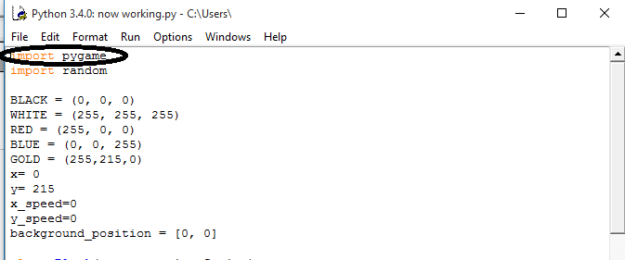

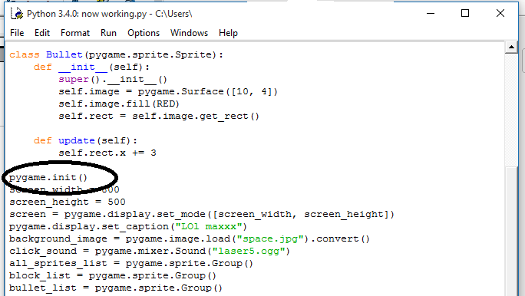

Colors:

We need to add variables that define our program's colors.Colors are defined in a list of three colors:red,green,blue(RGB).Each element of the triad is a number ranging from 0 to 255.Zero means there is none of the color but 255 means maximum intensity of the color.
For eg,
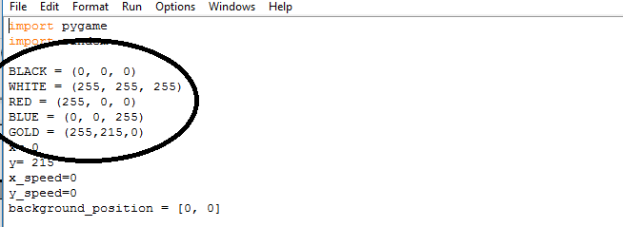

In this example,you will notice that all the color variables are named in capital letters. This is because,they are constant.Since we know from our earlier chapter that variables whose values don't change are written in capital letters.

Opening a Window:

Below is the code to create a window sized to a width of 800 pixels and a height of 500 pixels and set its title to “LOl maxxx”.
Screen is made to behave like an object.

screen_width = 800
screen_height = 500
screen = pygame.display.set_mode([screen_width, screen_height])
pygame.display.set_caption("LOl maxxx") # to set the title of the window

User Interaction with game:

With the codes written above you won't able to do much thing. These codes will just open a window with the given title and then program will hang. Now we need that runs until the user wants to close it and we also want to take user inputs through keyboard and mouse and incorporate in our program, we will also be drawing some graphics.All these tasks will go into this loop . The best loop for this task seems to be “while ” loop,which will exit on user's wish(here in our case if he clicks close button on the opened game window).
The basic code for all these tasks is given below.
# Loop until the user clicks the close button.
done = False
# Used to manage how fast the screen updates
clock = pygame.time.Clock()
# -------- Main Program Loop -----------
while not done:
# --- Main event loop
for event in pygame.event.get(): # User did something
if event.type == pygame.QUIT: # If user clicked close
done = True # Flag that we are done so we exit this loop
# --- Game logic should go here
# --- Drawing code should go here
# First, clear the screen to white. Don't put other drawing commands
# above this, or they will be erased with this command.
screen.fill(WHITE)
# --- Go ahead and update the screen with what we've drawn.
pygame.display.flip()
# --- Limit to 60 frames per second
clock.tick(60)

Now below is a snapshot of the codes in our game:

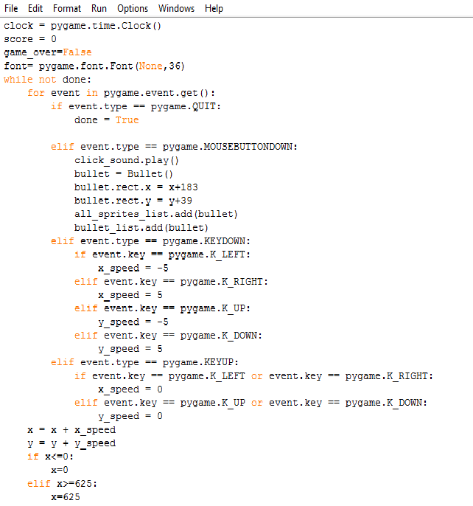

Event Processing loop:
The “event processing” code handles all the keystrokes, mouse button clicks, and several other types of events. For example your loop might look like:

for event in pygame.event.get():
if event.type == pygame.QUIT:
done = True

elif event.type == pygame.MOUSEBUTTONDOWN:
click_sound.play()
bullet = Bullet()
bullet.rect.x = x+183
bullet.rect.y = y+39
all_sprites_list.add(bullet)
bullet_list.add(bullet)
elif event.type == pygame.KEYDOWN:
if event.key == pygame.K_LEFT:
x_speed = -5
elif event.key == pygame.K_RIGHT:
x_speed = 5
elif event.key == pygame.K_UP:
y_speed = -5
elif event.key == pygame.K_DOWN:
y_speed = 5
elif event.type == pygame.KEYUP:
if event.key == pygame.K_LEFT or event.key == pygame.K_RIGHT:
x_speed = 0
elif event.key == pygame.K_UP or event.key == pygame.K_DOWN:
y_speed = 0

The events (like pressing keys) all go together in a list. The program uses a for loop to loop through each event. Using a chain of if statements the code figures out what type of event occurred, and the code to handle that event goes in the if statement.

Processing each frame:

The basic logic and order for each frame of the game:
- While not done:
  - For each event (keypress, mouse click, etc.):
    - Use a chain of if statements to run code to handle each event.
  - Run calculations to determine where objects move, what happens when objects collide, etc.
  - Clear the screen
  - Draw everything
The drawing of graphics happens in the while loop. With the clock set to 60 it will draw the contents 60 times per second.
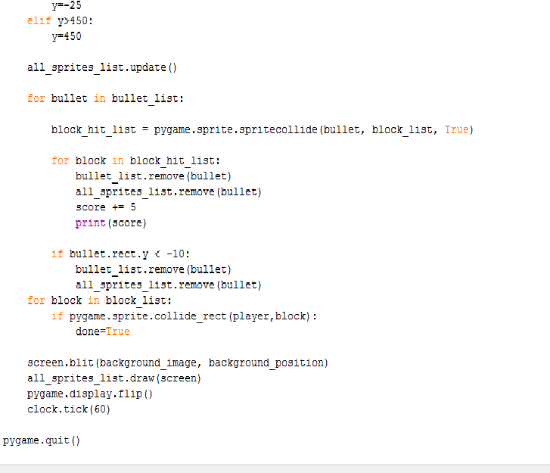
Program ending:
pygame.quit() wil tell the program to exit and close the window.

Clearing the screen:
Before drawing anything we need to be sure that our board is clean on which we are going to draw the images. Same concept applies here also,before drawing we clear the screen using the following code.
screen.fill(WHITE)
But note that this code should be written well before the codes for drawing images are written.
Screen lipping:
Very important! You must flip the display after you draw. The computer will not display the graphics as you draw them because it would cause the screen to flicker. This waits to display the screen until the program has finished drawing. The command below “flips” the graphics to the screen.
pygame.display.flip()
Failure to include this command will mean the program just shows a blank screen. Any drawing code after this flip will not display.

Drawing Introduction:
Using pygame library we can draw lines rectangles, lines,circles ,ellipse etc.
Following are the code syntax to draw them.
Draw rectangle
pygame.draw.rect(Surface, color, Rect, width=0): return Rect
eg. pygame.draw.rect(screen, RED, [55, 50, 20, 25])
will draw rectangle on “screen” with “Red ” boundaries and top left corner at (55,50 )pixel coordinates,width of 20 pixels and height of 25 pixels.
pygame.draw.rect(screen, RED, [55, 50, 20, 25], 0)
Draw line
pygame.draw.line(screen, GREEN, [0, 0], [100, 100], 5)
It will draw a line of green color on screen starting from (0,0) and ending at (100,100) with a width of 5 pixels.
Draw ellipse
pygame.draw.ellipse(screen, BLACK, [20,20,250,100], 2)
Draw arc
pygame.draw.arc(screen, GREEN, [100,100,250,200], PI/2, PI, 2)
Draw polygon
pygame.draw.polygon(screen, BLACK, [[100,100], [0,200], [200,200]], 5)

